**Experiment 1:**

Uniform Acceleration

**Name:** Omar Ozgur

**Date:** October 5, 2015 (10/05/15)

**Lab:** Section 1, Monday 9am

**TA:** Hector Garcia

**Lab Partner(s):** Christie Matthews

**Introduction**

The purpose of this experiment was to determine if the acceleration of an object is uniform when a constant force is applied in one direction. In order to test this phenomenon, we set up a glider on a horizontal air track that minimized friction. Then we attached string to the glider, and draped the free end of the string across a pulley. We were able to carry out the experiment by attaching various weights to the free end of the string, and letting them fall to the floor. The falling weights caused tension in the string, which pulled the glider along the track.

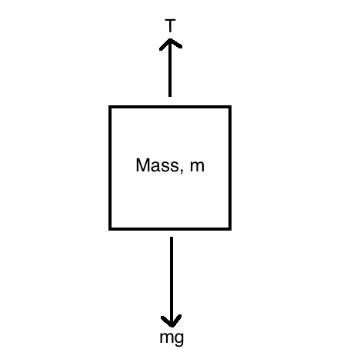

Figure : Free-body Diagram of Hanging Weight: Gravity acts on the mass, causing a downward force. An upward force is caused by tension in the string.

Figure 2: Free-body Diagram of Glider: Gravity acts on the mass, causing a downward force. An upward force due to the air in the air track nearly cancels out the downward force. Tension in the string causes force in the horizontal axis.

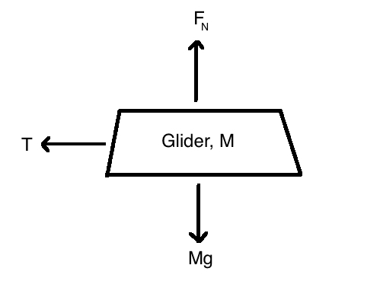

In order to predict the acceleration of the glider, we can begin with Newton’s Second Law, which can be summarized by the equation:

F = ma (Eq. 1.1)

Since friction is minimized between the glider and the track, as well as between the string and the pulley, we can see that gravity is free to act on the mass and the glider without much impedance. This leads to a new equation:

mg = (m + M)a (Eq. 1.2)

We can now isolate the acceleration.

$a=\frac{gm}{m+M}$ (Eq. 1.3)

Since the masses “m” and “M” have uncertainties in their measurements, we must calculate the uncertainty of a, δa, as follows:

$δ\left(m+M\right)=\sqrt{δm^{2}+ δM^{2}}$ (Eq. 1.4)

$δ\left(gm\right)=|g|δm$ (Eq. 1.5)

$δa=|a_{best}|\sqrt{{\left(\frac{δ(m+M)}{|m_{best}+M_{best}|}\right)}^{2}+{\left(\frac{δ(gm)}{|m_{best}g|}\right)}^{2}}$ (Eq. 1.6)

$δa=|a_{best}|\sqrt{{\left(\frac{\sqrt{δm^{2}+ δM^{2}}}{|m_{best}+M_{best}|}\right)}^{2}+{\left(\frac{δm}{|m_{best}|}\right)}^{2}}$ (Eq. 1.7)

Equations 1.3 and 1.7 can be used to calculate the predicted acceleration of the glider during the experiment.

**Experimental Results and Data Analysis**

In order to carry out the experiment, we began by measuring the masses of the weights, as well as the mass of the glider.

|  |  |  |  |  |  |
| --- | --- | --- | --- | --- | --- |
| Mass 1 (g) | Mass 2 (g) | Mass 3 (g) | Mass 4 (g) | Mass 5 (g) | Mass of Glider (g) |
| 3.4 ± 0.1 | 4.9 ± 0.1 | 19.5 ± 0.1 | 34.7 ± 0.1 | 39.5 ± 0.1  (Measured 2 masses together) | 199.9 ± 0.14 |

Table 1: Masses of Weights and Glider: These masses were measured with a gram scale, with uncertainty in the first decimal place. In cases where a counter-balance was used, equation ii.14 was used to calculate the propagation of uncertainties.

After recording the masses, we set up the air track and adjusted the height on one side in order to keep it horizontal. Then we attached string to the glider, and draped it over a smart pulley system at the end of the track. By attaching weights to the free end of the string, and letting them drop to the floor, we were able to measure the velocity of the glider, which we used to calculate acceleration. The full setup is shown in figure 3 below.

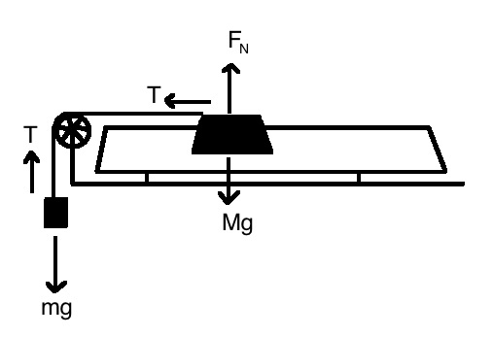

Figure 3: Experiment Setup: The diagram displays the setup of the experiment, as well as the forces that were generated.

Smart

Pulley

Air Track

Glider

Weight

The pulley that we used was able to record the time and “block count” every time a spoke on the pulley blocked the built-in sensor. By using the DAQ system, we obtained a table of times and block counts for 5 different trials (one trial for each weight). In order to calculate the distance that the pulley moved between block counts, we used the following equation in the lab manual:

KSP = (1.50 ± 0.05) cm/block (Eq. 1.8)

Equation 1.8 allows for the conversion of block counts to positions. To calculate the change in velocity of the glider during each trial, we needed to calculate the change in position between block counts, as well as the changes in time, as shown in the equations below.

Δx = xi+1 - xi (Eq. 1.9)

Δt = ti+1 - ti (Eq. 2.0)

By using equations 1.3 and 1.4, we are able to find an equation for the average velocity between every 2 points.

$\overline{v}= \frac{Δx}{Δt}= \frac{x_{i+1}-x_{i}}{t_{i+1}-t_{i}}$ (Eq. 2.1)

In order to graph acceleration, we needed to also find the average time between every 2 points.

$\overline{t}= \frac{t_{i}+t_{i+1}}{2}$ (Eq. 2.2)

By using the average times and velocities to form a graph, and analyzing the trend lines of each data set, we were able to analyze the acceleration of the glider during each trial.

Figure 4: Changes in Velocity Over Time: Every dot in each of the 5 trials represents the velocity of the glider at a given time. As more weight was introduced, the velocities grew more rapidly over time. The trend lines (with equations shown on the graph) can be described by the general equation, v = at + v0.

Based on the trend line equations in figure 4, we see that the slopes of the lines represent the average acceleration of the glider during each of the trials. Since all of the dots lie very close to the trend lines, we can visually see that the acceleration was nearly constant during the runs.

In order to further analyze the results of the experiment, we can compare the measured accelerations with predicted accelerations. To begin, we first do a linear regression on each set of data in order to find the uncertainties in the accelerations. Then, we can use equations 1.3 and 1.7 to calculate abest,as well as the uncertainty, δa. The following table shows the predicted accelerations, measured accelerations, and the differences between them.

|  |  |  |  |
| --- | --- | --- | --- |
| Mass (g) | Predicted Acceleration (cm/s2) | Measured Acceleration (cm/s2) | Difference in Acceleration (cm/s2) |
| 3.4 ± 0.1 | 16.4 ± 0.5 | 14.49 ± 0.08 | 1.9 ± 0.5 |
| 4.9 ± 0.1 | 23.4 ± 0.5 | 21.8 ± 0.1 | 1.6 ± 0.5 |
| 19.5 ± 0.1 | 87.1 ± 0.5 | 81.9 ± 0.9 | 5 ± 1 |
| 34.7 ± 0.1 | 144.9 ± 0.4 | 135 ± 2 | 10 ± 2 |
| 39.5 ± 0.1 | 161.7 ± 0.4 | 157 ± 3 | 5 ± 3 |

Table 2: Difference in Predicted and Measured Accelerations: The predicted acceleration values were calculated using equations 1.3 and 1.7. The measured accelerations were found by doing linear regression analysis on the trend lines in figure 4. The smaller the difference in these acceleration values, the more we can see that our hypothesis about uniform acceleration is true.

**Conclusion**

The main purpose of the experiment was to see if a constant force would cause uniform acceleration of an object. As seen in table 2, the predicted and measured accelerations were only off by a few cm/s2. The small differences show that the predictions based on equations 1.3 and 1.7 were relatively accurate. The larger error in the 4th trial is small outlier, and may have shown slower measured acceleration during the experiment due to a number of factors, such as swinging of the weights, or signal delays by the pulley sensor.

Though the measured results are very close to what was expected, a few main sources of error contributed to the differences that were observed. One source of systematic uncertainty was due to the gram scale that we used. The scale was only accurate to the nearest 0.1 gram. Improving accuracy when weighing is important, because a larger mass would have caused increased acceleration of the glider, while a smaller mass would have decreased acceleration.

Another source of systematic uncertainty would be the angle of the string going from the glider to the pulley. In order to maximize horizontal force on the glider, the string should be as horizontal as possible. If the string was slightly pulling upward or downward on the glider, there would be less force in the horizontal axis, causing decreased acceleration of the glider.

One other factor that may have skewed results was air resistance during the movement of the glider. While the glider moved along the track, collisions with air particles may have slightly slowed it down. Although this source of error is likely not very large, the effect could be minimized by decreasing surface area of the glider along the axis of the track.

**Extra Credit**

In order to calculate average velocity for the original chart in figure 4, equation 2.1 was used:

$\overline{v}= \frac{Δx}{Δt}= \frac{x_{i+1}-x_{i}}{t_{i+1}-t_{i}}$ (Eq. 2.1)

To calculate the average acceleration by directly plotting it, equation 2.1 can be differentiated once more, creating the following equation:

$\overline{a}= \frac{Δv}{Δt}= \frac{v_{i+1}-v_{i}}{t_{i+1}-t_{i}}$ (Eq. 2.3)

By plotting the average acceleration vs. the average time, we can directly see the change in acceleration over time. The linear trend lines from figure 4 suggest that the points on the new graph should theoretically form a horizontal line, indicating minimal change in acceleration.

Figure 5: Graph of Acceleration Over Time: The points on the graph show the acceleration of the glider at a given time. The data that was used was gathered from the first trial, which used the 3.4g mass.

Although the points on the graph start off in a horizontal manner, the acceleration values spread out as time goes on. The fact that many of these values are exactly 0 indicates that the fluctuations may be due to inaccuracy involving the numbers that were calculated. For example, in order to calculate average velocity, raw position and time data was used. However, in order to calculate acceleration in this new method, the average velocity was used, which is not raw data. The increasing uncertainty due to new layers of calculations is the probable cause of the odd point distribution in figure 5.

The best-measured value for acceleration can now be found be taking the mean of the average acceleration values, as shown in equation ii.11 in the lab manual.

$\overline{a}= \frac{1}{N}\sum_{i=1}^{N}{a_{i}}$ (Eq. 2.4)

This equation gives an average acceleration of 14.25 cm/s2. In order to calculate the uncertainty, we can use equation ii.13 from the lab manual.

$δa= \frac{1}{\sqrt{N}}\sqrt{\frac{1}{N-1}\sum_{i=1}^{N}{{\left(a_{i}-\overline{a}\right)}^{2}}}$ (Eq. 2.5)

Equation 2.5 gives an uncertainty of ± 4 cm/s2.

|  |  |  |
| --- | --- | --- |
| Acceleration Based on Slope (cm/s2) | Acceleration Based on Differentiation (cm/s2) | Difference in Acceleration (cm/s2) |
| 14.49 ± 0.08 | 14 ± 4 | 0 ± 4 |

Although the difference between the calculated accelerations is small, it is clear that the acceleration calculated by differentiation method introduces much more error than the error that was calculated with the slope of the trend line in figure 4. This shows that the original method of calculating acceleration was more accurate, and should be used instead of this method.

Table 3: Acceleration Calculated by Different Methods: The table shows the comparison between the acceleration that was found by analyzing the slope of the trend line in figure 4, and the acceleration that was found by differentiation the velocity equation.